DATA ANALYTICS WITH POWER BI

“ANALYSIS OF COMMERCIAL ELECTRICITY IN INDIAN STATES”

Nanjil Catholic College Of Arts And Science Kaliyakkavilai

|  |  |
| --- | --- |
| **NM ID** | **NAME** |
| **4F8494638A984A9B16A 48D0EF9435621** | **PRIYADHARSHINI P S** |

Trainer Name: R Uma Maheshwari

Master trainer: R Uma Maheshwari

**ABSTRACT**

**In the digital age, data has become an invaluable asset for commercial sectors . The proposed project , “Analysis of Commercial Electricity in Indian States” aims to leverage Power BI, a leading commercial intelligence tool to analysis and visualize commercial electricity consumption in Indian States. India is one of the fastest developing country in the world. To sustain this growth energy and electricity demands will increase. Models were tested on data from previous year and adjusted accordingly. On the electricity production side, all scenarios stress the role of coal renewable and nuclear source.**

**INDEX**

|  |  |  |
| --- | --- | --- |
| **S. No.** | **Table of Contents** | **Page No.** |
| **1.** | **Chapter I: Introduction** | **2** |
| **2.** | **Chapter II: Services and Tools Required** | **3** |
| **3.** | **Chapter III: Project Architecture** | **4** |
| **4.** | **Chapter IV: Modeling and Result** | **5** |
| **5.** | **Conclusions** | **8** |
| **6.** | **Future Scope** | **8** |

**CHAPTER I**

**INTRODUCTION**

**Electricity infrastructure and production are important for a developing economy like that of India with which a population of 1.2 billion and area of 329 million km2 is the seventh largest country in the world. From several scenarios we decided to introduce two possibilities, i.e., a scenario using high energy saving in all sector and a scenario counting on a high industrial growth not supported by an equal increase of electricity saving.**

**Problem Statement:**

**Historically, inadequate generation capacity was the key contributor to power defect. However, generation capacity has improved in the last few years due to high participation by the private sector. Over the years, the capacity to generate electricity has increased, however, the actual generation of electricity has not been commensurate with this increased capacity. Key reason for the low utilization of generation capacity are storage of fuel, especially, coal and unviable power purchase agreements.**

**Proposed Solution:**

**Planning and policy reforms involving scarcity management to one of flexible resiliency. Need to introduce feedback loops in ecosystem incentives to achieve or exceed complaints, but repercussions if they don’t. Policy focus must be on long term structural solutions addressing distribution financial viability coupled with Robust mechanism for resource planning. India should enhance investments in clean coal technologies deployment through- out coal value chain.**

**Advantages:**

**Good power density of 3 phase ac power networks. Power on demand that functionally draws only the power required by the load from the sources. Self test and monitoring easy to implement. Easy dynamic re-configuration of the power path for supplying users.**

**CHAPTER:II**

**SERVICE AND TOOLS REQUIRED**

**Services Used:**

**Software tools like excel, Python with libraries such as Pandas or specialized energies analytical platforms to process and analysis the electricity usage data. These tools can help in statistical analysis, trend identification and visualization of data. GIS software can be helpful for spatial analysis, mapping electricity consumption, patterns across different regions within the state and identifying areas with high or low consumption rates.**

**Tools and Software Used:**

***Tools***

**Power BI: The main tool for this project is Power BI, which will be used to create interactive dash boards for commercial data visualization.**

**Power Query: This is the data connection technology that enable us to discover, connect, combine and refine data across the wide variety of sources.**

***Software Requirements***

**Power BI Desktop: This is the windows application that we can use create reports and publish them to Power BI.**

**Power BI Service: This is an online SaaS service that we use to publish reports, create dash boards and share insights.**

**Power BI Mobile: This is a mobile application that we can use to assess our reports and dash boards on the go.**

**CHAPTER III**

**PROJECT ARCHITECTURE**

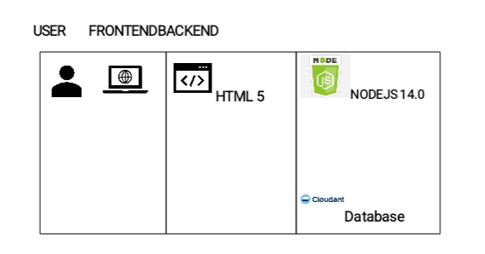

**Data Collection:**

**Gathering data on electricity consumption, demand patterns, pricing structures and distribution network.**

**Data Processing:**

**Processing the collected data to identify trends, consumption patterns and demand-supply gap.**

**GIS Mapping:**

**Utilizing GIS tool map distribution network, identify areas with high consumption and assess infrastructure requirements.**

**Demand Forecasting:**

**Employing statistical models and machines, learning algorithms to forecast electricity demands based on historical data, economical indicators and seasonal variations.**

**Cost-Benefit Analysis:**

**Conducting a cost benefit analysis of various strategies for improving electricity supply, including infrastructure investments, renewable energy integration and demand-side management programs**

**This architecture provides a comprehensive solution for commercial electricity consumption in Indian States.**

**CHAPTER IV**

**MODELLING AND RESULT**

**The disp file will be used as the main connector as it contains most key identifier which can be used to 8 data files together. The district file is used to link the client profile geographically with district ID.**

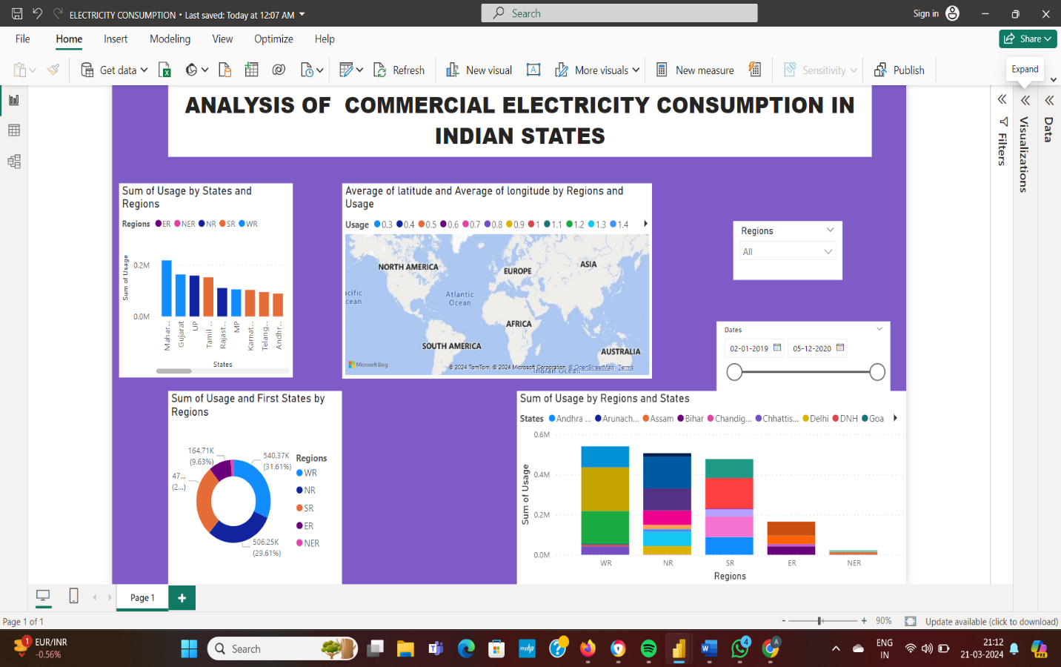

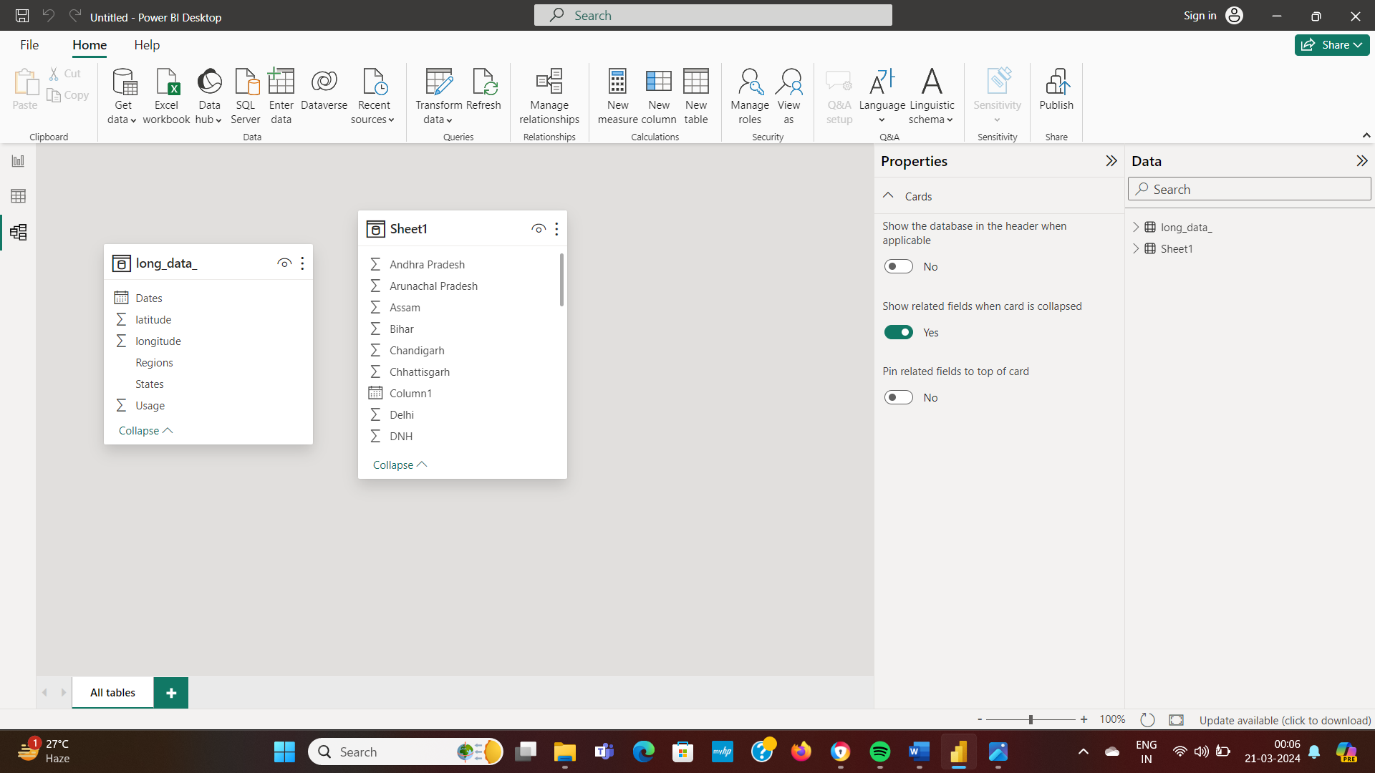

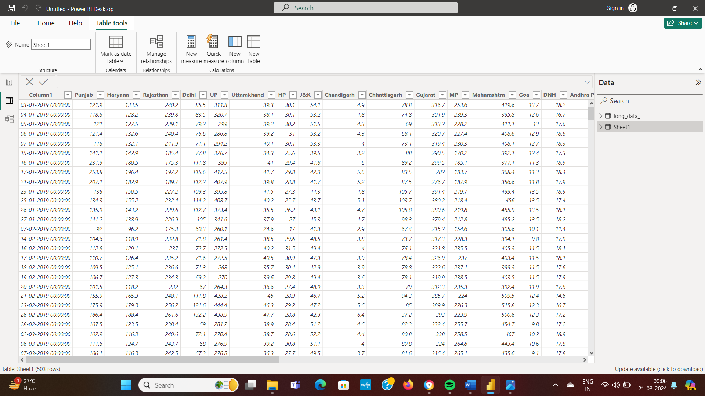

**CONCLUSION**

**The project “Analysis of Commercial Electricity in Indian States” using Power BI has successfully demonstrated the potential of data analytics in the commercial electricity sector. The analysis of customer data has provided valuable insights into customer behavior, preferences and trends, thereby facilitating informed decision-making. The interactive dashboard and reports have offered a comprehensive view of customer data, enabling the identification of patterns and correlations. This has not only improved the efficiency of data analysis but also enhanced the nation’s ability to provide personalized services to its customers. The project has also highlighted the importance of data visualization in making complex data more understandable and accessible.**

FUTURE SCOPE

The future scope of this project is vast. With the advent of advanced analytics and machine learning’ power BI can be leveraged to predict future trends based on historical data. Leveraging power BI’s analytics capabilities to identify operational inefficiencies, optimize asset performance, and streamline processes across the commercial electricity value chain, leading to cost savings and improved service delivery. By harnessing power BI’s advanced analytics, visualization, and reporting features, stakeholders in the commercial electricity sector of Indian states can gain valuable insights, drive data-driven decision-making, and navigate the evolving energy landscape with confidence and agility.

**Reference:**

**Link:**